June 18, 2019
Dear Parents,
The unit on Finite resources has now come to an end and we would like to give you some feedback.
UNIT: The children looked at how Mauritius and Rodrigues are managing finite resources sustainably. They went on a field trip to the Solar Farm in Mont Choisy and, on the way; we had a look at the windfarm in Bras D’eau. The children asked many questions and most of them showed interest during the trip. These field trips were organised so that children could compare their findings with what they were going to discover while in Rodrigues. Obviously, the most important field trip was RODRIGUES.
Indeed, the children were very much on task during the trip. The tourists at the hotel complimented them about their exemplary behaviour. The field trips went on very well despite the bad weather. We were able to go to the market on Saturday for the shopping. They had their shopping list and some of them constantly looked at their list to make sure they did not spend more than planned!
Most of the children were very eager to share their findings with their teacher during reflection time every afternoon. The feedback after the visit to the Primary School in Port Sud Est reflected the children’s sense of empathy. They mingled with the children easily and were amazed to see that the children were happy with so little.
The summative assessment, which was a comparative study of resource management in Mauritius and Rodrigues, showed that most of the children have grasped the enduring understanding of the unit.
- An identification of the finite/natural resources
- Their importance in everyday life
- The management of these resources- policy decisions.
- The reasons behind these decisions
- How the measures are similar in both context- Mauritius and Rodrigues
- How the measures are different in both contexts- Mauritius and Rodrigues
- The reasons for these differences

LANGUAGE: In writing, the children have been looking at argumentative writing. They have been analysing argumentative texts to identify the claim, argument and counter argument. Some children still have some issues finding the right word. Indeed, vocabulary is, again, something the children need to develop further. We reiterate our request that the children read for at least 30 minutes every day and keep a personal dictionary. Furthermore, children need to read different texts from a wide range of genres.

MATHS: The children have been looking at fractions, decimals and percentages. They have had opportunities to understand the relationship between speed, time and distance. The children need to keep on practising their multiplication and division facts at home. They also looked at bearing and the use of scale for measuring distance on a map.

Moreover, we are encouraging the children to be independent learners as they need to be risk takers and proactive for the upcoming exhibition. We have already begun to discuss prospective topics they can work on for the exhibition.

The home learning menu for the month of June as well as the Newsletter for the new unit is already online. The children have to submit their home learning logs and their reading journals every Friday.

Please spend quality time with your child.

Find some snapshots of our trip to Rodrigues. Please note that the pictures do not include all the Year 6 children as they are only showing some moments from our trip.

Cheers,

Year 6 Team

Coming back from Rodrigues

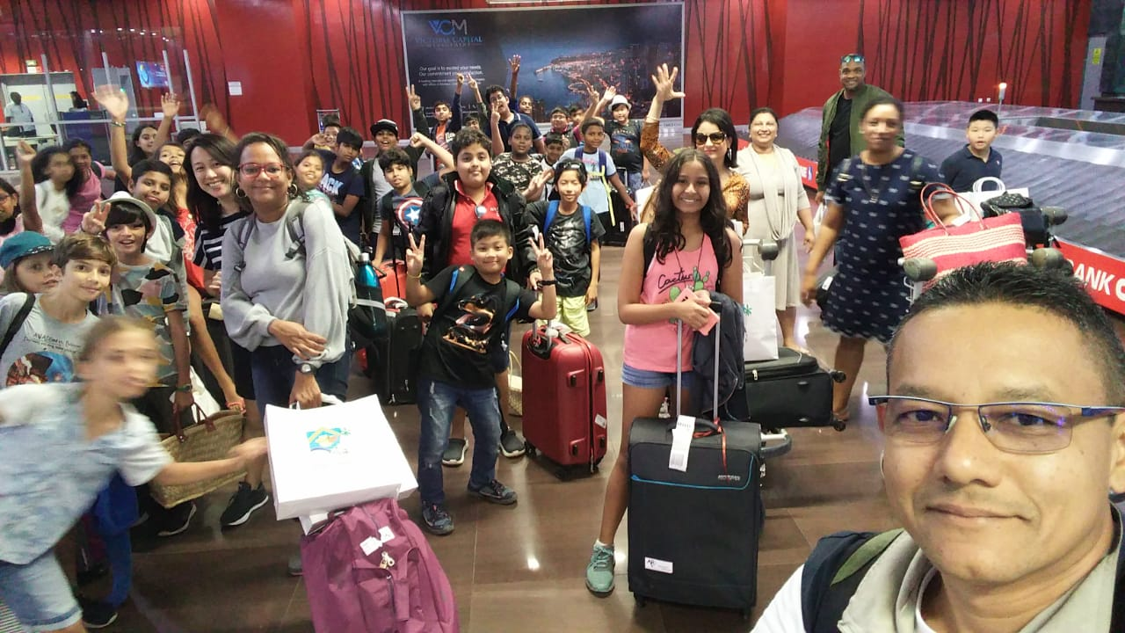

Morning Fitness

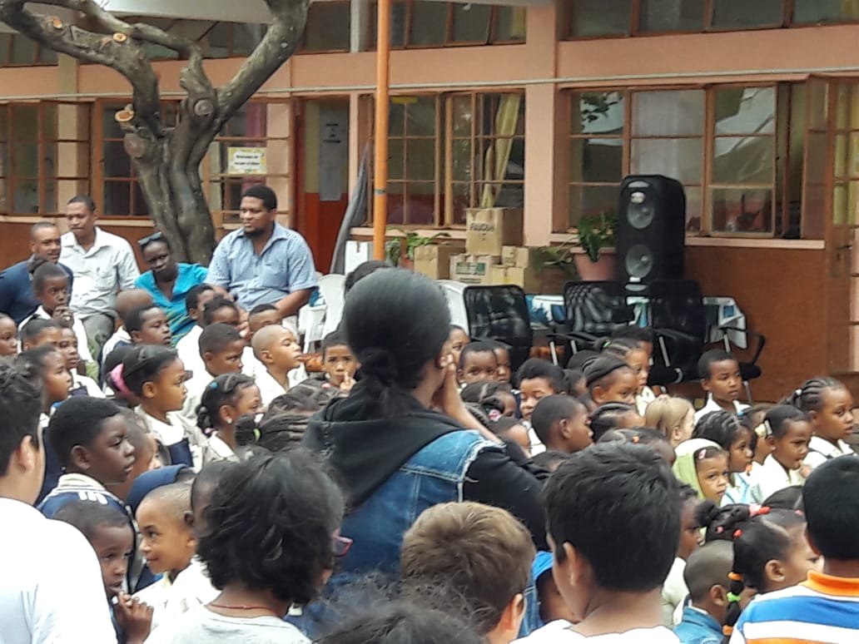
Visit of Port Sud Est Government School
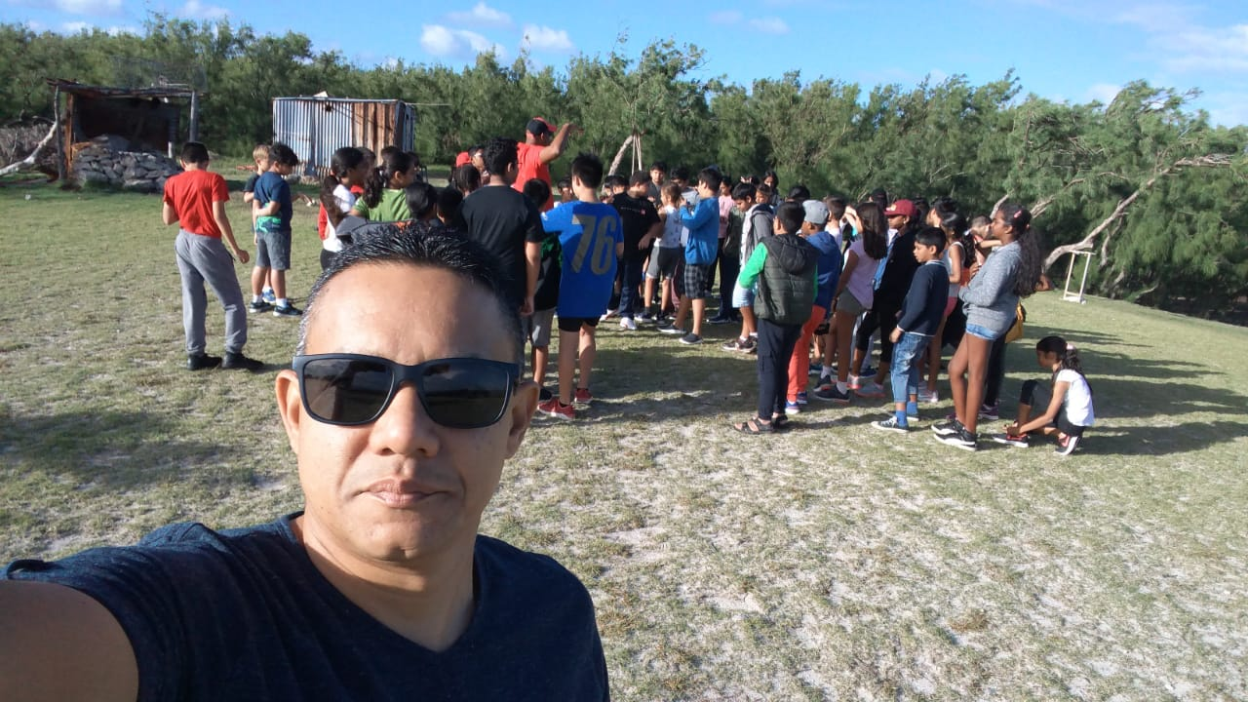

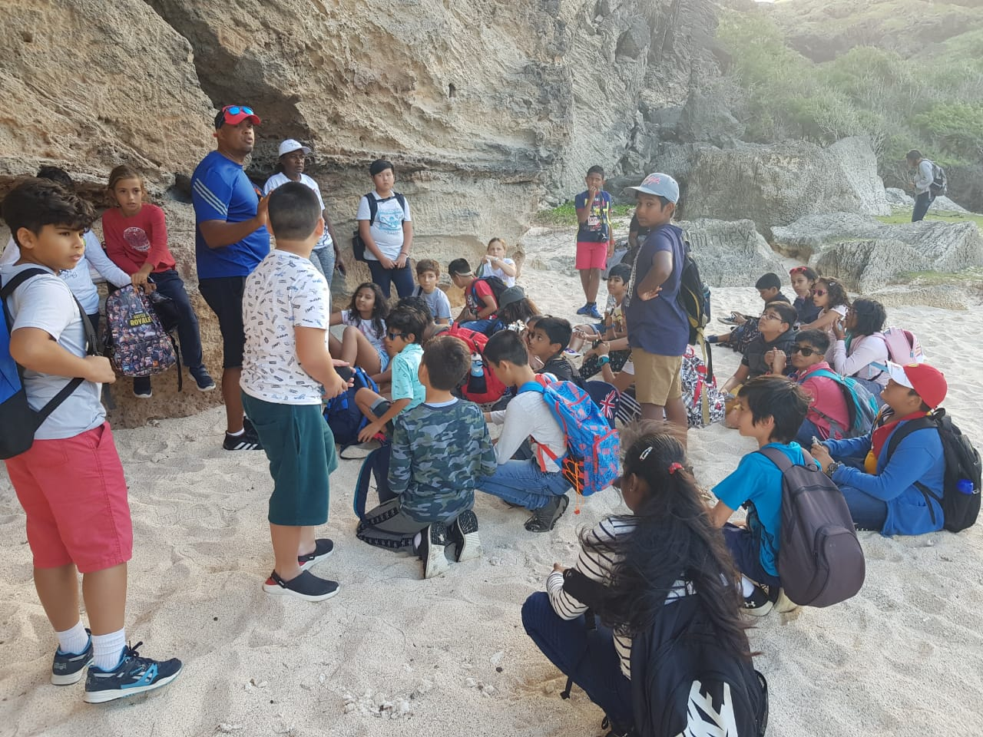

Listening to the legend of Trou D’Argent

Windmill at Grenade

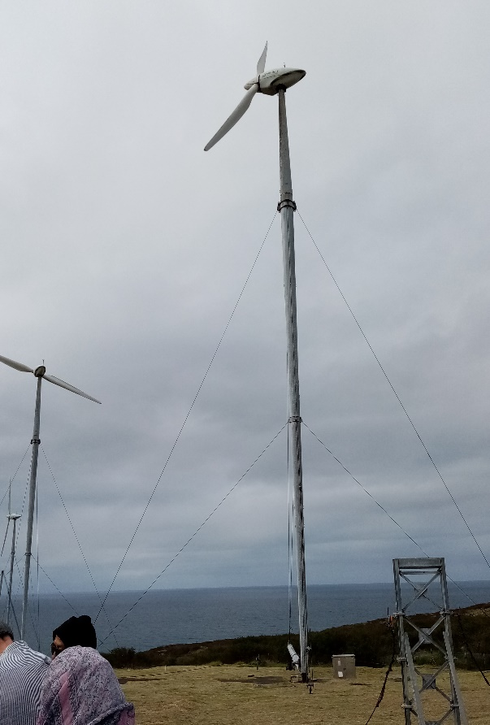
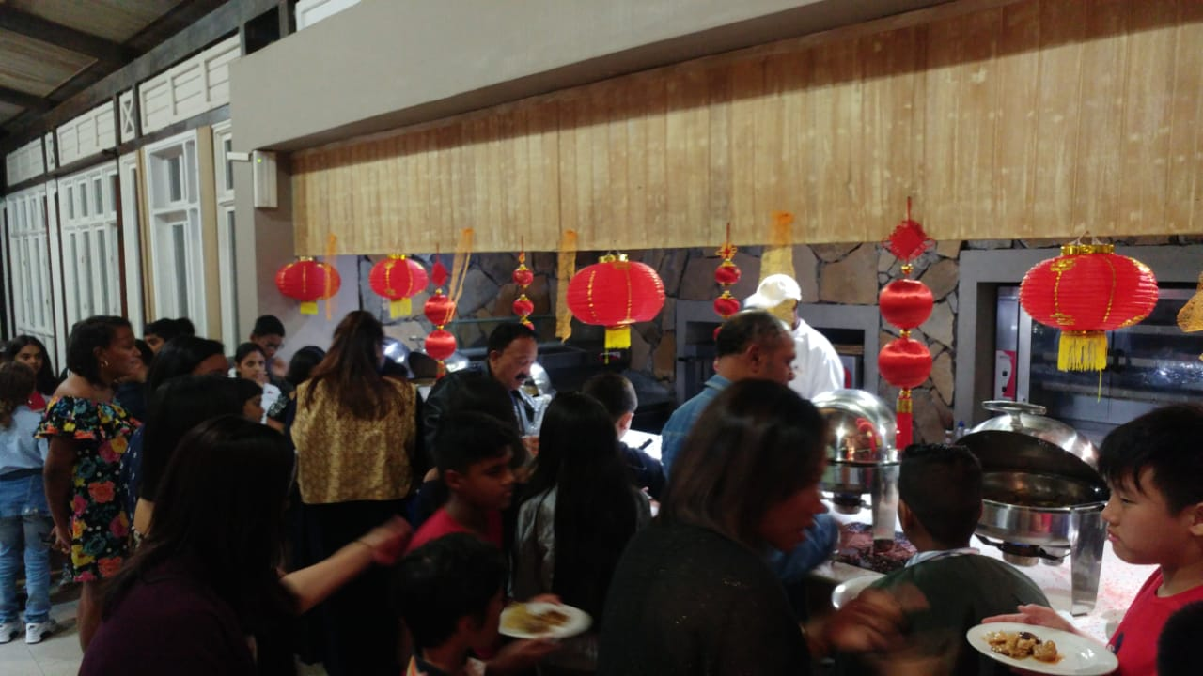

Dinner at Cotton Bay Hotel

