Home Learning Menu for the month of February
Please note that learners will have to do at least one piece of work per week. They can submit their work every week to the teacher. The menu is valid until _________________.
In year 6 you are expected to read for at least 30 minutes every day. You are also expected to write regularly in your writer’s notebook. Use ideas from Ralph Fletcher’s A Writer’s Notebook to add new entries regularly.
Writing - Writer’s Notebook  Use the ideas from Ralph Fletcher’s A Writer’s Notebook to write regularly. Write a new entry everyday. As you see your notebook grow, you will also be growing as a writer.  Write:  - Unforgettable stories  - Fierce wonderings  - Writing small  - Seed ideas  - Mind Pictures  - Snatches of talk  - Lists  - Memories  - Writing that scrapes the heart  - Writing that inspires | Writing – Vocabulary  Ways of walking  There are many synonyms of walk. Some examples are stroll, pace saunter, trek, tiptoe etc,  - Use a thesaurus to find as many synonyms of walk as you can.  - Use a dictionary to find the meaning of each word.  - Act out each way of walking to show how they are different.  - Use five of the synonyms in sentences.  - Follow the link to watch the video that explains the meaning of each synonym of walk.  https://youtu.be/O0D4h5lViF8 | Writing – Spelling  Learn how to spell the words you will be using in the unit “Art Forms” using any strategy you know.  The words are:  Foreground, background, perspective, metaphor, simile, alliteration, personification, sculpture, aesthetic, editing, photography, painter, rhythm, rhyme, cubism, impressionism, portrait, ceramics, design, crafts, literature, biography, autobiography, ballet, theatre, opera, landscape, sketch, museum, gallery.
Reading  Choose any one of the ways to respond to a story you have read:  - Write a letter to the author to tell her/him what you liked or didn’t like about the story.  - Write a letter to a friend to persuade him/her to read the story.  - Write a letter to one of the characters in the story to say what you liked or didn’t like about her/him.  Make your letter exciting to read by adding some interesting details. | Maths Challenge  Have fun solving this puzzle.  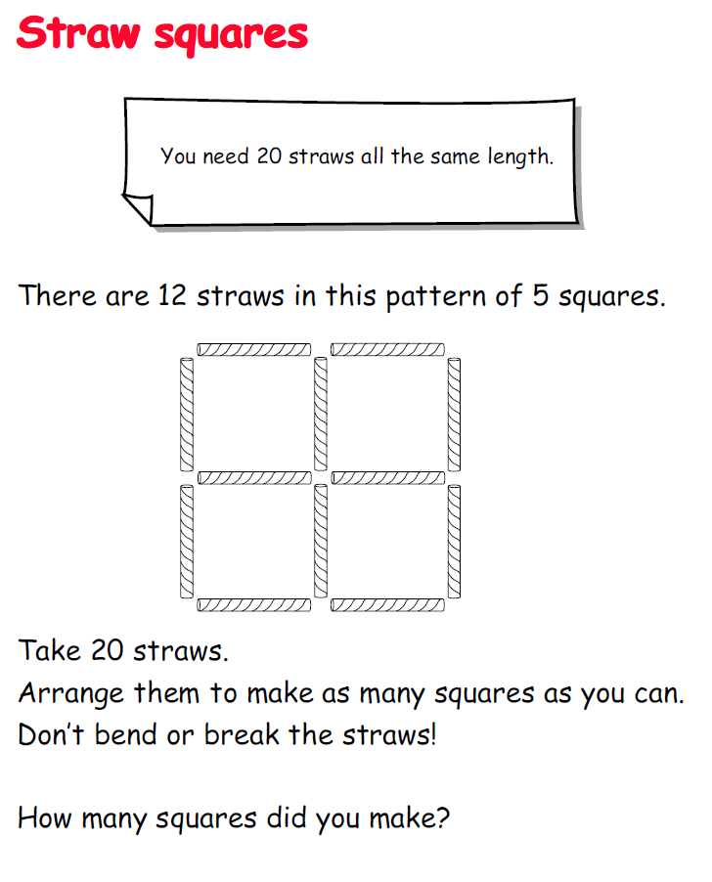  Draw a picture of your solution in your home learning log. | Personal Inquiry:  Make a thorough research into any topic of your own choice.  Think of a creative way to share your findings with your classmates or schoolmates during a morning assembly.
Guided Inquiry  Find out about an art form you know very little about.  Make a list of artists associated with this art form.  Create a timeline of how the art form evolved. | Maths  Centi-billionaire Bezos’ fortune rose to $112 billion, the biggest single-year gain ever, allowing him to dethrone Gates, worth just $90 billion. Gates has been the richest person in the world for 18 of the past 24 years.  (Source: USA Today)  How are big numbers used in real life? Find examples from the internet, magazines and newspapers.  Say the numbers aloud.  Write each number in as many ways as you can. | Maths Investigation  That’s Perfect!  People have been searching for number patterns since ancient times. Mathematicians noticed that some numbers are equal to the sum of all of their factors (but not including the number itself).  6 is a number that equals the sum of its factors: 1 + 2 + 3 equal 6.  Numbers like 6 that equal the sum of their factors are called perfect numbers.  6 is the first perfect number .  4 is not a perfect number because the sum of its factors (besides 4 itself), 1+2, is less than 4. Numbers like 4 are known as deficient numbers.  12 is not a perfect number because the sum of its factors, 1+2+3+4+6 is greater than 12. Numbers like 12 are known as abundant numbers.  Since the time of Pythagoras (about 500 BC), mathematicians have tried to find as many perfect numbers as they can. By 1999 only 38 perfect numbers had been found.  Can you find the next perfect number after 6?
Observation skill  Observe something that changes over a week or a month. Draw and write short notes about the changes you observe:  Some examples of things that change are:  The moon  A leaf  A flower  A landscape | Maths and Language Drill  Select a worksheet from the home learning basket in class. | Visual Art  Copy as accurately as possible any artwork of your choice. This can be a painting, an illustration from a book, a portrait, a stamp, a poster etc.

