Home Learning Menu
Please note that learners will have to do at least one piece of work per week. You can submit your work every week to the teacher. The menu is valid until Tuesday, 12th November 2019.
- Free Writing | - Writing  Write a letter to a friend from Year 5, explaining the differences and similarities of each year group. Give them some tips and advice for moving into Year 6. | - Writing  Create a poem or a song to express your feelings about joining Secondary school next year. Try to include at least one rhyming couplet and be creative with your words.
- Reading  Select a book/ article of your choice to read and respond in your Reading Journal.  Did you enjoy reading it? Why / why not? | - Maths Facts  Knowing one multiplication fact means you also know two related division facts.  Because 8 x 4 = 32 you know that 32 ÷ 8 = 4 and 32 ÷ 4 = 8.  Write at least 8 multiplication and division facts. | - Creativity  Create your own rebus for the word, TRANSITION.  An example is above – can you figure it out?
- Maths Inquiry  Giving reasons, explain whether the following are true or false:  - Nineteen less than eleven is minus eight.  - -39 + 23 = -62  - The temperature is -5°C outside and 23°C inside. The difference is 18°C | - Reflection  Working in a group with my friends is always better than working with people I do not know or work with often.  Give reasons for both sides of this statement. | - Maths Challenge  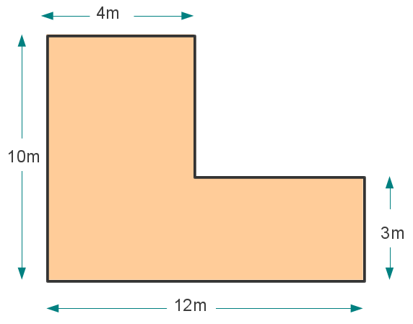  Find the perimeter and area the compound shape above.  Draw a compound shape with the perimeter of 32cm and an area of 48cm².
- Word Work  Create a word search using words related to transition and what it means to you. There are some examples below. Ask your teacher for the word search template.  Words: transition, change, moving, environment, emotions… | - Reflection  Choose two of the PYP Attitudes and write about how you have shown this attitude.  Appreciation / Enthusiasm / Cooperation / Creativity / Confidence / Commitment / Curiosity / Integrity / Empathy / Tolerance / Independence / Respect | - Visual Art  Create an A4 drawing of your journey through Year 6, showing emotions, important events, your friends, etc.  Please make sure it is coloured in neatly.

Word search

Find the words below:

____________________________
____________________________
____________________________
____________________________
____________________________
____________________________
____________________________
____________________________
____________________________
____________________________

